Ujian Akhir Praktikum - Semester Ganjil 2018/2019
Practicum Final Exam - Odd Semester Year 2018/2019
Matakuliah  Subject |  | COMP6153 - Operating System |  |  | 
Kelas  Class | : BT01 |  | Tanggal  Date | : 1/12/2019
Dosen  Lecturer | : D1279 - Tatang Gunar Setiadji, M.Eng. |  | Waktu  Time | : 07.20 - 09.00

PERATURAN UJIAN:
Exam Regulations:
- Mahasiswa tidak diperbolehkan membuka BUKU atau catatan apapun
Student is not allowed to open or use any books or notes
- Mahasiswa tidak diperbolehkan menggunakan disket/flash disk/tempat penyimpanan data apapun di dalam ruangan ujian
Student is not allowed to use disc/flash disc/or any other storage devices in exam room
- Mahasiswa tidak diperbolehkan berdiskusi dengan peserta ujian lainnya
Student is not allowed to discuss with other exam participants
- Asisten BERHAK memberi nilai 0 (NOL) bagi peserta ujian yang melakukan segala bentuk kecurangan
Assistant is able to give 0 (ZERO) score for exam participant who does any cheating actions
- Kumpulkan jawaban dan soal tepat pada waktunya
Submit the case and answer on time
- Bila Anda tidak membaca peraturan ini, maka Anda dianggap telah membaca dan menyetujuinya
If you have missed to read these regulations, so you are considered to have read and agreed on it

PERHATIAN!
Attention!
- Kerjakan sesuai dengan soal
Work in accordance with the exam case
- Bagi yang mengerjakan tidak sesuai dengan soal akan diberikan sanksi sebagai berikut:
For those who do not work in accordance with the exam case will be punished as follows:
      - Jika ada penilaian logika, maka penilaian logika adalah NOL (0)
If there is logic marking, it will be marked as ZERO (0)
      - Untuk penilaian yang lain (selain logika) akan dikalikan setengah dari nilai yang diperoleh
Another marking (beside logic) will be multiplied by half the value obtained

Important Notes:
- Use your own Console and Scheduler (FIFO).
- You must use Semaphore to control operation.
- You must use Timer to generate tick of time.
- Use KThread.

Soal
Case

ToDo List
Mr. TD wants to develop an app named ToDo List in BlueJack land, Mr. TD wanted to make an application with the intention of managing Mr. TD’s tasks. The features provided in this application are insert, view and complete task. As a programmer, you are asked to create the application using nachOS in Java programming language.
In the start of the application, the program will look for a file named “task.txt” which will be converted into an acceptable task data and load it into the system with the help of file system if the file is available.
After the said process has been completed, the application will then show 4 menus which represent features in the application which are:
- Insert Task
- View Task
- Complete Task
- Exit
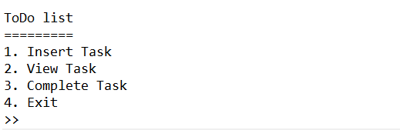
Figure 1. Main menu
- Insert Task
The first menu option let the user inserts a new task into the system. This option requires the user to input information regarding the task that follows the following detail which are:
- Ask the user to input Task’s Title. The task’s title must be between 5 and 15 characters.
Figure 2. Title input
- Ask the user to input Task’s Description. The task’s description must contains at least 2 words.
Figure 3. Description input
- Ask the user to input Task’s type. The task’s type must be “Important”, or “Unimportant” (Case Insensitive).
Figure 4. Type input
- After all the required input has been filled, the task’s status will set to “Not Done”, and show success message to the user.
Figure 5. Success message
- View Task
The second option of the menu (View Task) allows the user to view all data in the system. The process follows the following steps which are:
- Check if book list has any data. If the book list didn’t have any data, the application will show an error message to the user.

- Otherwise, if the task list already filled or have a task data, the application will show all task.
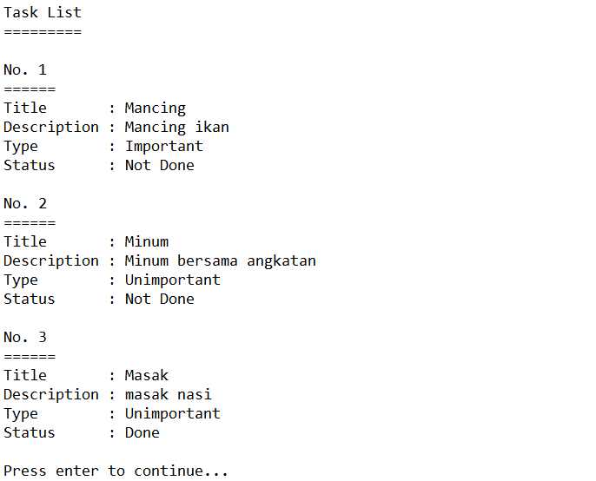
Figure 6. View all data

- Complete Task
The third option in the menu allows the user to complete an uncompleted task from the list. The completing process follows the following steps which are:
- Check if there at least one uncompleted task in task list. If there is no any uncompleted task in the list, the application will show an error message to the user.

- Otherwise, the application will print all uncompleted task only on task list and ask the user what index of a task that want to be completed. The index starts from 1 to number of uncompleted task(s).
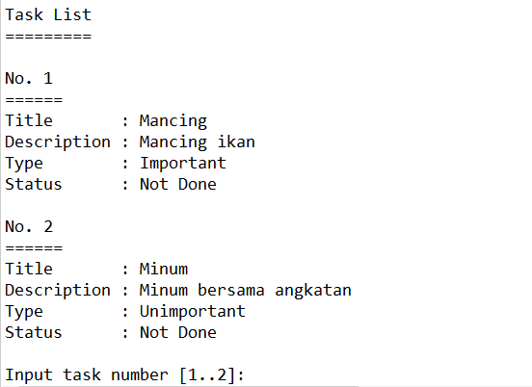
Figure 7. View uncompleted task
- After the process has been completed successfully, Update the task’s status to “Done” using KThread and direct the user back to the main menu.
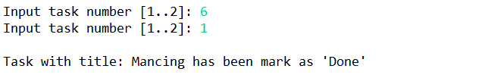
Figure 8. Complete task
- Exit
If the user chooses the forth Menu (Exit), the application will print tick of time in second using a timer.
Figure 9. Exit

